Administration

Barbara S. Effman, MPH
Chair

John A. Benz, MBA
Vice Chair

Samuel F. Morrison, BA, MLS
Secretary

Mark Dissette, MBA
Treasurer

Pamela B. Africk
Lee Chaykin, FACHE
Osmel Delgado, MBA, PharmD, FASHP
C. Kennon Hetlage, FACHE
Vince L. Johnson, MPH
Albert C. Jones, MA
Leilani Kicklighter, MBA, ARM, RN
Cary Zinkin, DPM

Michael De Lucca, MHM
President and CEO

Equal Opportunity Employer

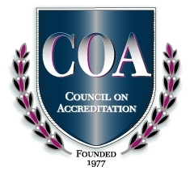

M E M O R A N D U M

TO: BRHPC Board of Directors

FROM: Michael De Lucca, President and CEO

DATE: DATE: August 26, 2020

SUBJECT: BRHPC Board Meeting, September 10, 2020 at 5:30 p.m.

BRHPC’s Board of Directors Meeting will be held on Thursday, September 10, 2020 at 5:30 p.m. via Microsoft Teams. In preparation for that meeting, you will find the following documents:

Agenda (Exhibit A)
Minutes of May 14, 2020 (Exhibit B)
Treasurer’s Report (Exhibit C)
Scorecards (Exhibit D)
Strategic Plan (Mailed on 8/10/2020 under separate cover)
Executive Committee Minutes (Exhibit E)

Please make every effort to participate and be sure to review the meeting material. The Teams meeting information will be emailed to you via Outlook.

Should you have any questions, please let me know. We look forward to our meeting on September 10th.

MD/ymf

Enclosures

